Chapter 17, Solution 22.

Calculate the Fourier coefficients for the function in Fig. 17.60.

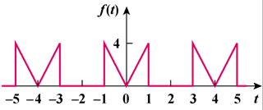

Figure 17.60
For Prob. 17.22.

Solution

Calculate the Fourier coefficients for the function in Fig. 16.54.

t

5

4

3

2

1

0

-1

-2

-3

-4

-5

4

f(t)

Figure 16.54 For Prob. 16.15

This is an even function, therefore b_{n} = 0. In addition, T=4 and ω_{o} = π/2.

a_{o} = 1

a_{n} =

a_{n} =

